RESUME

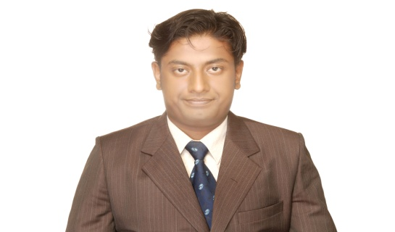
NAME : Ashish . R . Rajput

ADDRESS : 35 Highwaypark Society

Opp. Acher Depo ,

Rambaughroad Ramnagar

Sabarmati AHMADABAD- 380005

Mobile No : 9898617187

Work EXPERIEnce

- Worked with Motif India Pvt Ltd ( BPO ) as an C .S. R (Customer Service Representative).Working as an Backend Executive for Make My Trip Travel portal for Central Operational (Work Related to Hotels, Flight, Cab and all Travel One Stop Solution shop). ( Year 2012-2014 )

- Also Worked for Medusind Solutions ( BPO ) as an customer service Representative . Handling Dental Works Department for U.S.A based Insurance (Client) firm as Credentialing and claim Process Executive. And also worked for medical R.C.M . Experienced of Credentialing and claim Process. ( Year 2014-2015 )

- Currently Working for Azure Knowledge Corp. PVT . LTD , in VisionAsia Project . Australian And New ZeeLand base IPTV Box Project . Working as an Backend Executive. Handling Sales & Account Quires of Vision Asia Customer. ( Year April 2016 to Current ) .

Educations QUALIFICATION:
- H.S.C. from Firdaus Amrut School (G.S.E.B – 2007) from English Medium 61 %.
- Completed Bachelor in commerce (B.COM) from (Gujarat University - 2011) from English Medium 55 %

Academic QUALIFICATION:
- DCA (Diploma in Computer Application) in Mar 2010, from ALMA Organization. WITH DISTINCTION.
- Completed, Training in Aviation, Hospitality, Travel & Tourism (HNC, Certified U.K.) From Frankfin Institute of Air Hostess & Flight Stewards Training, Completed IN Dec 2010.

- Languages i kNOW

English, Hindi, Gujarati .

- Date of Birth :

16th May 1988

Key Result Area
- Excellent Communication Skill, well skilled in Computer application related software’s & best for every team leading assignment’s given to me in my job premises.

ACKNOWLEDGEMENT:
- I Promise to work hard and politely towards the every Assignment given to me in my job Premises, with the output to do my best.

